**SIKSHA ‘O’ ANUSANDHAN**

**DEEMED TO BE UNIVERSITY**

**Admission Batch: 2019 Session: 2020-2021**

**End-Term Project Report**

**Computer Science Workshop (CSE 3141)**

**Submitted by:**

Name: ***RIYA DUTTA***

Registration No.: ***1941012185***

Branch: ***CSE***

Semester: ***3rd***  Section: ***C***



**`**

**Department of Computer Science & Engineering**

**Faculty of Engineering & Technology (ITER)**

**Jagamohan Nagar, Jagamara, Bhubaneswar, Odisha – 751030**

|  |  |  |
| --- | --- | --- |
| **SL.NO** | **Topics** | **Page No.** |
| **1** | Problem Statement | 3 |
| **2** | Problem Analysis | 4 |
| **3** | Flow Chart | 5 |
| **4** | Coding (JAVA as programming language) | 6 |
| **5** | Screenshot of the program | 36 |

**CONTENTS**

**Problem Statement:**

Municipal Data Management System This project is a simple Municipal Data Management System. In this project you will be learning how to add new person record to the database, how to generate a 5 digit unique ID for each person, how to remove a person from active list to the dead person list if you are issuing death certificate, person location in the given ward. Also, you will be implementing the following operations add, view, show status, etc. The status will show all the details of the person including name, id, date of birth, occupation, family type (single or joint).

**Problem Analysis:**

From the problem statement it is clear that we have to build a GUI based java program which connects to any kind of Realtional Database Management System (RDMS), using which the user should be able to login to database and can edit or delete data based on type of user i.e., General or Administrator User.

To connect to the database here MySql we need Java Database Connectivity (JDBC) which is an API for Java. We can use JDBC API to access tabular data stored in any relational database. By the help of JDBC API, we can save, update, delete and fetch data from the database.

We need to create multiple frame using Java Swing. Starting from log in so that the user can log in to database. In the problem statement it is clear that there have to be 2 kinds of users i.e., General and Admin Users. The General User can only view his details and can not edit his or her details nor can he or she export or see the table whereas the Admin user can edit his or her details and can also see and export the table to a txt file. There will also be an option so that a General User can upgrade to a Admin User so that he can also use the functions available for Admin User.

**Flow chart of the problem:**

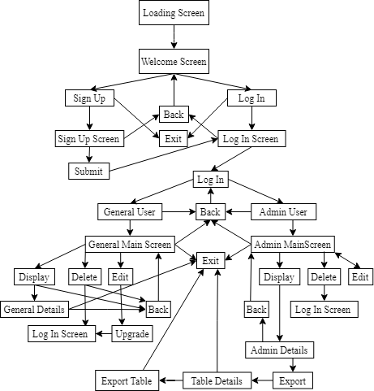

**Coding:**

/*

Name - Riya

Registration ID - 1941012185

Branch & Section - CSE C

*/

import java.awt.Color;

import java.awt.Font;

import java.awt.event.ActionEvent;

import java.awt.event.ActionListener;

import java.io.File;

import javax.swing.BorderFactory;

import javax.swing.ImageIcon;

import javax.swing.JButton;

import javax.swing.JComboBox;

import javax.swing.JFrame;

import javax.swing.JLabel;

import javax.swing.JOptionPane;

import javax.swing.JPasswordField;

import javax.swing.JProgressBar;

import javax.swing.JScrollPane;

import javax.swing.JSeparator;

import javax.swing.JTable;

import javax.swing.JTextField;

import javax.swing.SwingConstants;

import javax.swing.table.DefaultTableModel;

import java.sql.Connection;

import java.sql.DriverManager;

import java.sql.ResultSet;

import java.sql.SQLException;

import java.sql.Statement;

class LoadingScreen extends JFrame {

    JProgressBar load;

    JLabel mm, loading;

    LoadingScreen() {

        mm = new JLabel("MUNICIPAL MANAGEMENT SYSTEM");

        mm.setBounds(28, 15, 350, 71);

        mm.setFont(new Font("Cooper Black", Font.PLAIN, 18));

        mm.setForeground(new Color(0x45A29E));

        loading = new JLabel("Loading...");

        loading.setBounds(165, 80, 200, 25);

        loading.setFont(new Font(" ", Font.PLAIN, 16));

        loading.setForeground(new Color(0xC5C6C7));

        load = new JProgressBar();

        load.setBackground(new Color(0x1f2833));

        load.setForeground(new Color(0xC5C6C7));

        load.setBorder(BorderFactory.createLineBorder(new Color(0x66fcf1)));

        load.setBounds(125, 110, 150, 25);

        this.add(load);

        this.add(mm);

        this.add(loading);

        this.setUndecorated(true);

        this.setSize(400, 200);

        this.setResizable(false);

        this.setLocationRelativeTo(null);

        this.setLayout(null);

        this.getContentPane().setBackground(new Color(0x1f2833));

        this.setVisible(true);

        try {

            for (int i = 0; i <= 100; i++) {

                Thread.sleep(45);

                load.setValue(i);

                if (i == 100) {

                    new WelcomeScreen();

                    this.setVisible(false);

                }

            }

        } catch (Exception e) {

            e.printStackTrace();

        }

    }

}

class WelcomeScreen extends JFrame implements ActionListener {

    JSeparator div;

    JButton log, signup, exit;

    JLabel su, li, welcome;

    WelcomeScreen() {

        div = new JSeparator();

        div.setOrientation(SwingConstants.VERTICAL);

        div.setBounds(224, 185, 200, 150);

        div.setBackground(new Color(0xC5C6C7));

        div.setForeground(null);

        li = new JLabel("New User ?");

        li.setFont(new Font("Cooper Black", Font.PLAIN, 13));

        li.setForeground(new Color(0xC5C6C7));

        su = new JLabel("Existing User ?");

        su.setFont(new Font("Cooper Black", Font.PLAIN, 13));

        su.setForeground(new Color(0xC5C6C7));

        welcome = new JLabel("WELCOME");

        welcome.setBounds(55, 75, 350, 71);

        welcome.setFont(new Font("Cooper Black", Font.PLAIN, 60));

        welcome.setForeground(new Color(0x45A29E));

        signup = new JButton("Sign Up");

        signup.setFont(new Font(" ", Font.PLAIN, 15));

        signup.setBorder(BorderFactory.createLineBorder(new Color(0x66fcf1)));

        signup.setForeground(new Color(0x45A29E));

        signup.setBackground(new Color(0x1f2833));

        signup.addActionListener(this);

        signup.setFocusable(false);

        exit = new JButton("EXIT");

        exit.setFont(new Font(" ", Font.PLAIN, 15));

        exit.setBorder(BorderFactory.createLineBorder(new Color(0x1f2833)));

        exit.setForeground(new Color(0x45A29E));

        exit.setBackground(new Color(0x1f2833));

        exit.addActionListener(this);

        exit.setFocusable(false);

        log = new JButton("Log In");

        log.setFont(new Font("", Font.PLAIN, 15));

        log.setBorder(BorderFactory.createLineBorder(new Color(0x66fcf1)));

        log.setForeground(new Color(0x45A29E));

        log.setBackground(new Color(0x1f2833));

        log.addActionListener(this);

        log.setFocusable(false);

        this.add(div);

        this.add(exit);

        this.add(welcome);

        this.add(li);

        this.add(su);

        this.add(signup);

        this.add(log);

        this.setUndecorated(true);

        this.setSize(448, 448);

        this.setResizable(false);

        this.setLocationRelativeTo(null);

        this.setLayout(null);

        this.getContentPane().setBackground(new Color(0x1f2833));

        this.setVisible(true);

        log.setBounds(260, 250, 70, 25);

        signup.setBounds(100, 250, 70, 25);

        li.setBounds(100, 200, 100, 25);

        su.setBounds(260, 200, 120, 25);

        exit.setBounds(385, 5, 45, 45);

    }

    @Override

    public void actionPerformed(ActionEvent e) {

        if (e.getSource() == signup) {

            this.setVisible(false);

            new SignUp();

        }

        if (e.getSource() == log) {

            this.setVisible(false);

            new LogIn();

        }

        if (e.getSource() == exit)

            System.exit(0);

    }

}

class SignUp extends JFrame implements ActionListener {

    JTextField enterName, enterID;

    JLabel username, id, pass, type, signUp, icon, idError;

    JPasswordField pf;

    JButton submit, back, exit;

    JSeparator userLine, idLine, passLine;

    JComboBox cb;

    String user[] = { "General", "Administrator" };

    SignUp() {

        signUp = new JLabel("Create Account");

        signUp.setBounds(25, 45, 400, 51);

        signUp.setFont(new Font("Cooper Black", Font.PLAIN, 50));

        signUp.setForeground(new Color(0x45A29E));

        username = new JLabel("User Name");

        username.setBounds(55, 95, 200, 30);

        username.setFont(new Font("Cooper Black", Font.PLAIN, 13));

        username.setForeground(new Color(0x45A29E));

        enterName = new JTextField();

        enterName.setBorder(BorderFactory.createLineBorder(new Color(0x1f2833)));

        enterName.setBackground(new Color(0x1f2833));

        enterName.setForeground(new Color(0xC5C6C7));

        enterName.setBounds(55, 120, 200, 30);

        userLine = new JSeparator();

        userLine.setOrientation(SwingConstants.HORIZONTAL);

        userLine.setBounds(55, 150, 200, 30);

        userLine.setBackground(new Color(0xC5C6C7));

        userLine.setForeground(null);

        id = new JLabel("User ID");

        id.setBounds(55, 155, 200, 30);

        id.setFont(new Font("Cooper Black", Font.PLAIN, 13));

        id.setForeground(new Color(0x45A29E));

        enterID = new JTextField();

        enterID.setBorder(BorderFactory.createLineBorder(new Color(0x1f2833)));

        enterID.setBackground(new Color(0x1f2833));

        enterID.setForeground(new Color(0xC5C6C7));

        enterID.setBounds(55, 180, 200, 30);

        idLine = new JSeparator();

        idLine.setOrientation(SwingConstants.HORIZONTAL);

        idLine.setBounds(55, 210, 200, 30);

        idLine.setBackground(new Color(0xC5C6C7));

        idLine.setForeground(null);

        pass = new JLabel("Password");

        pass.setBounds(55, 215, 200, 30);

        pass.setFont(new Font("Cooper Black", Font.PLAIN, 13));

        pass.setForeground(new Color(0x45A29E));

        pf = new JPasswordField();

        pf.setBorder(BorderFactory.createLineBorder(new Color(0x1f2833)));

        pf.setBackground(new Color(0x1f2833));

        pf.setForeground(new Color(0xC5C6C7));

        pf.setBounds(55, 240, 200, 30);

        passLine = new JSeparator();

        passLine.setOrientation(SwingConstants.HORIZONTAL);

        passLine.setBounds(55, 270, 200, 30);

        passLine.setBackground(new Color(0xC5C6C7));

        passLine.setForeground(null);

        type = new JLabel("Select type of user");

        type.setBounds(55, 275, 200, 30);

        type.setFont(new Font("Cooper Black", Font.PLAIN, 13));

        type.setForeground(new Color(0x45A29E));

        cb = new JComboBox(user);

        cb.setBorder(BorderFactory.createLineBorder(new Color(0x1f2833)));

        cb.setBackground(new Color(0x1f2833));

        cb.setForeground(new Color(0xC5C6C7));

        cb.setBounds(55, 310, 110, 30);

        exit = new JButton("EXIT");

        exit.setFont(new Font(" ", Font.PLAIN, 15));

        exit.setBorder(BorderFactory.createLineBorder(new Color(0x1f2833)));

        exit.setForeground(new Color(0x45A29E));

        exit.setBackground(new Color(0x1f2833));

        exit.addActionListener(this);

        exit.setFocusable(false);

        exit.setBounds(385, 5, 45, 45);

        submit = new JButton("SUBMIT");

        submit.setFont(new Font(" ", Font.PLAIN, 15));

        submit.setBorder(BorderFactory.createLineBorder(new Color(0x66fcf1)));

        submit.setForeground(new Color(0x45A29E));

        submit.setBackground(new Color(0x1f2833));

        submit.addActionListener(this);

        submit.setFocusable(false);

        submit.setBounds(55, 355, 90, 30);

        back = new JButton("< BACK");

        back.setFont(new Font(" ", Font.PLAIN, 15));

        back.setBorder(BorderFactory.createLineBorder(new Color(0x1f2833)));

        back.setForeground(new Color(0x45A29E));

        back.setBackground(new Color(0x1f2833));

        back.addActionListener(this);

        back.setFocusable(false);

        back.setBounds(15, 5, 90, 45);

        this.add(passLine);

        this.add(idLine);

        this.add(userLine);

        this.add(exit);

        this.add(signUp);

        this.add(username);

        this.add(id);

        this.add(pass);

        this.add(type);

        this.add(enterName);

        this.add(enterID);

        this.add(pf);

        this.add(back);

        this.add(submit);

        this.add(cb);

        this.setUndecorated(true);

        this.setSize(448, 448);

        this.setResizable(false);

        this.setLocationRelativeTo(null);

        this.setLayout(null);

        this.getContentPane().setBackground(new Color(0x1f2833));

        this.setVisible(true);

    }

    @Override

    public void actionPerformed(ActionEvent e) {

        if (e.getSource() == submit) {

            try {

                String url = "jdbc:mysql://127.0.0.1:3308/info";

                String username = "root";

                String password = "riya";

                Class.forName("com.mysql.jdbc.Driver");

                Connection con = DriverManager.getConnection(url, username, password);

                Statement stm = con.createStatement();

                if (enterID.getText().length() == 5) {

                    String sql = "INSERT INTO management (ID,Name,Password,UserType) values ("

                            + Integer.parseInt(enterID.getText()) + ",'" + enterName.getText() + "','" + pf.getText()

                            + "','" + (String) cb.getSelectedItem() + "')";

                    stm.executeUpdate(sql);

                    JOptionPane.showMessageDialog(null, "User created");

                    this.setVisible(false);

                    new LogIn();

                } else {

                    enterID.setText("");

                    idError = new JLabel("ID should be of length 5");

                    idError.setFont(new Font(" ", Font.PLAIN, 13));

                    idError.setForeground(new Color(0x66fcf1));

                    idError.setBounds(55, 210, 200, 30);

                    this.add(idError);

                    pass.setBounds(55, 230, 200, 30);

                    pf.setBounds(55, 255, 200, 30);

                    passLine.setBounds(55, 280, 200, 30);

                    type.setBounds(55, 285, 200, 30);

                    cb.setBounds(55, 320, 110, 30);

                    submit.setBounds(55, 360, 90, 30);

                }

            } catch (Exception E) {

                E.printStackTrace();

            }

            try {

                String url = "jdbc:mysql://127.0.0.1:3308/info";

                String username = "root";

                String password = "riya";

                Class.forName("com.mysql.jdbc.Driver");

                Connection con = DriverManager.getConnection(url, username, password);

                String query = "select ID, name from management";

                Statement st = con.createStatement();

                ResultSet rs = st.executeQuery(query);

                rs.next();

                System.out.println("data retrieved");

                con.close();

                System.out.println("closed");

            } catch (Exception E) {

                System.out.println(E);

            }

        }

        if (e.getSource() == back) {

            this.setVisible(false);

            new WelcomeScreen();

        }

        if (e.getSource() == exit)

            System.exit(0);

    }

}

class LogIn extends JFrame implements ActionListener {

    JButton login, exit, back;

    JTextField usertf;

    JPasswordField pf;

    JLabel userid, pass, wrongPass, wrongid, log, copy;

    JSeparator userLine, passLine;

    LogIn() {

        log = new JLabel("Log In ");

        log.setBounds(55, 45, 300, 51);

        log.setFont(new Font("Cooper Black", Font.PLAIN, 50));

        log.setForeground(new Color(0x45A29E));

        userid = new JLabel("User ID");

        userid.setBounds(55, 95, 200, 30);

        userid.setFont(new Font("Cooper Black", Font.PLAIN, 13));

        userid.setForeground(new Color(0x45A29E));

        usertf = new JTextField();

        usertf.setBorder(BorderFactory.createLineBorder(new Color(0x1f2833)));

        usertf.setBackground(new Color(0x1f2833));

        usertf.setForeground(new Color(0xC5C6C7));

        usertf.setBounds(55, 120, 200, 30);

        userLine = new JSeparator();

        userLine.setOrientation(SwingConstants.HORIZONTAL);

        userLine.setBounds(55, 150, 200, 30);

        userLine.setBackground(new Color(0xC5C6C7));

        userLine.setForeground(null);

        pass = new JLabel("Password");

        pass.setBounds(55, 155, 200, 30);

        pass.setFont(new Font("Cooper Black", Font.PLAIN, 13));

        pass.setForeground(new Color(0x45A29E));

        pf = new JPasswordField();

        pf.setBorder(BorderFactory.createLineBorder(new Color(0x1f2833)));

        pf.setBackground(new Color(0x1f2833));

        pf.setForeground(new Color(0xC5C6C7));

        pf.setBounds(55, 180, 200, 30);

        passLine = new JSeparator();

        passLine.setOrientation(SwingConstants.HORIZONTAL);

        passLine.setBounds(55, 210, 200, 30);

        passLine.setBackground(new Color(0xC5C6C7));

        passLine.setForeground(null);

        exit = new JButton("EXIT");

        exit.setFont(new Font(" ", Font.PLAIN, 15));

        exit.setBorder(BorderFactory.createLineBorder(new Color(0x1f2833)));

        exit.setForeground(new Color(0x45A29E));

        exit.setBackground(new Color(0x1f2833));

        exit.addActionListener(this);

        exit.setFocusable(false);

        exit.setBounds(385, 5, 45, 45);

        back = new JButton("< BACK");

        back.setFont(new Font(" ", Font.PLAIN, 15));

        back.setBorder(BorderFactory.createLineBorder(new Color(0x1f2833)));

        back.setForeground(new Color(0x45A29E));

        back.setBackground(new Color(0x1f2833));

        back.addActionListener(this);

        back.setFocusable(false);

        back.setBounds(15, 5, 90, 45);

        login = new JButton("Log In");

        login.setFont(new Font(" ", Font.PLAIN, 15));

        login.setBorder(BorderFactory.createLineBorder(new Color(0x66fcf1)));

        login.setForeground(new Color(0x45A29E));

        login.setBackground(new Color(0x1f2833));

        login.addActionListener(this);

        login.setFocusable(false);

        login.setBounds(55, 230, 70, 30);

        wrongPass = new JLabel();

        wrongPass.setBounds(55, 225, 200, 30);

        wrongPass.setFont(new Font(" ", Font.PLAIN, 13));

        wrongPass.setForeground(new Color(0x66fcf1));

        wrongid = new JLabel();

        wrongid.setBounds(55, 150, 200, 30);

        wrongid.setFont(new Font(" ", Font.PLAIN, 13));

        wrongid.setForeground(new Color(0x66fcf1));

        this.add(passLine);

        this.add(exit);

        this.add(back);

        this.add(log);

        this.add(userid);

        this.add(userLine);

        this.add(pass);

        this.add(usertf);

        this.add(pf);

        this.add(login);

        this.add(wrongPass);

        this.add(wrongid);

        this.setUndecorated(true);

        this.setSize(448, 448);

        this.setResizable(false);

        this.setLocationRelativeTo(null);

        this.setLayout(null);

        this.getContentPane().setBackground(new Color(0x1f2833));

        this.setVisible(true);

    }

    @Override

    public void actionPerformed(ActionEvent e) {

        if (e.getSource() == back) {

            this.setVisible(false);

            new WelcomeScreen();

        }

        if (e.getSource() == exit)

            System.exit(0);

        if (e.getSource() == login) {

            try {

                Class.forName("com.mysql.jdbc.Driver");

                Connection con = DriverManager.getConnection("jdbc:mysql://127.0.0.1:3308/info", "root", "riya");

                Statement stm = con.createStatement();

                String enteredID = usertf.getText();

                ResultSet resultSet = stm.executeQuery("SELECT COUNT(*) AS rowcount FROM management;");

                resultSet.next();

                int rowCount = resultSet.getInt("rowcount");

                resultSet = stm.executeQuery("SELECT ID FROM management;");

                System.out.println("MyTable has " + rowCount + " row(s).");

                boolean logchk = false;

                String retrievepass = "";

                for (int i = 1; i <= rowCount; i++) {

                    while (resultSet.next()) {

                        if (enteredID.equals(resultSet.getString("ID"))) {

                            resultSet = stm

                                    .executeQuery("SELECT Password FROM management where ID='" + enteredID + "' ");

                            resultSet.next();

                            retrievepass = resultSet.getString("Password");

                            logchk = true;

                            break;

                        }

                    }

                }

                if (logchk) {

                    if (retrievepass.equals(pf.getText())) {

                        resultSet = stm.executeQuery("SELECT UserType FROM management where ID='" + enteredID + "' ");

                        resultSet.next();

                        if (resultSet.getString("UserType").equals("General")) {

                            this.setVisible(false);

                            new GeneralMainScreen(enteredID);

                        } else if (resultSet.getString("UserType").equals("Administrator")) {

                            this.setVisible(false);

                            new AdminMainScreen(enteredID);

                        }

                    } else {

                        pf.setText("");

                        login.setBounds(55, 250, 70, 30);

                        wrongPass.setText("Entered password is wrong !!!");

                    }

                } else {

                    pf.setText("");

                    usertf.setText("");

                    login.setBounds(55, 250, 70, 30);

                    wrongid.setText("Entered User ID is wrong !!!");

                    pass.setBounds(55, 170, 200, 30);

                    pf.setBounds(55, 195, 200, 30);

                    passLine.setBounds(55, 225, 200, 30);

                }

            } catch (Exception E) {

                E.printStackTrace();

            }

        }

    }

}

class GeneralMainScreen extends JFrame implements ActionListener {

    JButton edit, display, back, exit, upgradeBtn, delete;

    String ID, pn;

    JLabel editmsg, upgrade, confirm, copy, mm, profile, profileName;

    GeneralMainScreen(String id) {

        ID = id;

        mm = new JLabel("Municipal Management");

        mm.setBounds(15, 50, 450, 71);

        mm.setFont(new Font("Cooper Black", Font.PLAIN, 35));

        mm.setForeground(new Color(0x45A29E));

        exit = new JButton("EXIT");

        exit.setFont(new Font(" ", Font.PLAIN, 15));

        exit.setBorder(BorderFactory.createLineBorder(new Color(0x1f2833)));

        exit.setForeground(new Color(0x45A29E));

        exit.setBackground(new Color(0x1f2833));

        exit.addActionListener(this);

        exit.setFocusable(false);

        exit.setBounds(385, 5, 45, 45);

        back = new JButton("< BACK");

        back.setFont(new Font(" ", Font.PLAIN, 15));

        back.setBorder(BorderFactory.createLineBorder(new Color(0x1f2833)));

        back.setForeground(new Color(0x45A29E));

        back.setBackground(new Color(0x1f2833));

        back.addActionListener(this);

        back.setFocusable(false);

        back.setBounds(15, 5, 90, 45);

        profile = new JLabel();

        profile.setIcon(new ImageIcon("user3.png"));

        profile.setBounds(15, 115, 90, 45);

        try {

            Class.forName("com.mysql.jdbc.Driver");

            Connection con = DriverManager.getConnection("jdbc:mysql://127.0.0.1:3308/info", "root", "riya");

            Statement stm = con.createStatement();

            ResultSet rs = stm.executeQuery("SELECT Name FROM management WHERE ID = '" + ID + "'");

            rs.next();

            pn = rs.getString("Name");

        } catch (Exception E) {

            E.printStackTrace();

        }

        profileName = new JLabel(pn + " (General User)");

        profileName.setBounds(70, 115, 400, 45);

        profileName.setFont(new Font(" ", Font.PLAIN, 18));

        profileName.setForeground(new Color(0xC5C6C7));

        display = new JButton("DISPLAY");

        display.setFont(new Font(" ", Font.PLAIN, 15));

        display.setBorder(BorderFactory.createLineBorder(new Color(0x66fcf1)));

        display.setForeground(new Color(0x45A29E));

        display.setBackground(new Color(0x1f2833));

        display.addActionListener(this);

        display.setFocusable(false);

        display.setBounds(70, 180, 70, 30);

        edit = new JButton("EDIT");

        edit.setFont(new Font(" ", Font.PLAIN, 15));

        edit.setBorder(BorderFactory.createLineBorder(new Color(0x66fcf1)));

        edit.setForeground(new Color(0x45A29E));

        edit.setBackground(new Color(0x1f2833));

        edit.addActionListener(this);

        edit.setFocusable(false);

        edit.setBounds(70, 230, 70, 30);

        delete = new JButton("DELETE");

        delete.setFont(new Font(" ", Font.PLAIN, 15));

        delete.setBorder(BorderFactory.createLineBorder(new Color(0x66fcf1)));

        delete.setForeground(new Color(0x45A29E));

        delete.setBackground(new Color(0x1f2833));

        delete.addActionListener(this);

        delete.setFocusable(false);

        delete.setBounds(70, 280, 70, 30);

        editmsg = new JLabel("Only users of Admin Type can edit their data");

        editmsg.setFont(new Font("Cooper Black", Font.PLAIN, 12));

        editmsg.setForeground(new Color(0xC5C6C7));

        upgrade = new JLabel("Want to upgrade to Admin");

        upgrade.setFont(new Font("Cooper Black", Font.PLAIN, 12));

        upgrade.setForeground(new Color(0xC5C6C7));

        upgradeBtn = new JButton("UPGRADE");

        upgradeBtn.setFont(new Font(" ", Font.PLAIN, 15));

        upgradeBtn.setBorder(BorderFactory.createLineBorder(new Color(0x66fcf1)));

        upgradeBtn.setForeground(new Color(0x45A29E));

        upgradeBtn.setBackground(new Color(0x1f2833));

        upgradeBtn.addActionListener(this);

        upgradeBtn.setFocusable(false);

        this.add(back);

        this.add(exit);

        this.add(display);

        this.add(profile);

        this.add(editmsg);

        this.add(delete);

        this.add(upgrade);

        this.add(upgradeBtn);

        this.add(profileName);

        this.add(edit);

        this.add(mm);

        this.setUndecorated(true);

        this.setSize(448, 448);

        this.setResizable(false);

        this.setLocationRelativeTo(null);

        this.setLayout(null);

        this.getContentPane().setBackground(new Color(0x1f2833));

        this.setVisible(true);

    }

    @Override

    public void actionPerformed(ActionEvent e) {

        if (e.getSource() == delete) {

            try {

                String url = "jdbc:mysql://127.0.0.1:3308/info";

                String username = "root";

                String password = "riya";

                Class.forName("com.mysql.jdbc.Driver");

                Connection con = DriverManager.getConnection(url, username, password);

                Statement stm = con.createStatement();

                String sql = "DELETE FROM management WHERE id='" + ID + "';";

                stm.executeUpdate(sql);

                JOptionPane.showMessageDialog(null, "User Deleted !!!");

                this.setVisible(false);

                new WelcomeScreen();

            } catch (Exception E) {

                E.printStackTrace();

            }

        }

        if (e.getSource() == display) {

            this.setVisible(false);

            new generalDisplay(ID);

        }

        if (e.getSource() == exit)

            System.exit(0);

        if (e.getSource() == back) {

            this.setVisible(false);

            new LogIn();

        }

        if (e.getSource() == edit) {

            editmsg.setBounds(70, 310, 400, 30);

            upgrade.setBounds(70, 335, 400, 30);

            upgradeBtn.setBounds(70, 360, 80, 30);

        }

        if (e.getSource() == upgradeBtn) {

            try {

                Class.forName("com.mysql.jdbc.Driver");

                Connection con = DriverManager.getConnection("jdbc:mysql://127.0.0.1:3308/info", "root", "riya");

                Statement stm = con.createStatement();

                stm.executeUpdate("UPDATE management SET UserType = 'Administrator' WHERE ID = '" + ID + "';");

                this.setVisible(false);

                new LogIn();

            } catch (Exception E) {

                E.printStackTrace();

            }

        }

    }

}

class generalDisplay extends JFrame implements ActionListener {

    JButton back, exit;

    String ID;

    ResultSet rs;

    Statement stm;

    Connection con;

    JLabel labelID, labelNAME, labelPASS, labelUSERTYPE, labelOCCUPATION, labelDOB, labelFAMILY, labelSTATUS, display,

            copy;

    generalDisplay(String id) {

        ID = id;

        display = new JLabel("User Details");

        display.setBounds(55, 45, 450, 71);

        display.setFont(new Font("Cooper Black", Font.PLAIN, 50));

        display.setForeground(new Color(0x45A29E));

        exit = new JButton("EXIT");

        exit.setFont(new Font(" ", Font.PLAIN, 15));

        exit.setBorder(BorderFactory.createLineBorder(new Color(0x1f2833)));

        exit.setForeground(new Color(0x45A29E));

        exit.setBackground(new Color(0x1f2833));

        exit.addActionListener(this);

        exit.setFocusable(false);

        exit.setBounds(385, 5, 45, 45);

        back = new JButton("< BACK");

        back.setFont(new Font(" ", Font.PLAIN, 15));

        back.setBorder(BorderFactory.createLineBorder(new Color(0x1f2833)));

        back.setForeground(new Color(0x45A29E));

        back.setBackground(new Color(0x1f2833));

        back.addActionListener(this);

        back.setFocusable(false);

        back.setBounds(15, 5, 90, 45);

        labelID = new JLabel();

        labelID.setBounds(65, 100, 200, 30);

        labelID.setFont(new Font("Cooper Black", Font.PLAIN, 12));

        labelID.setForeground(new Color(0xC5C6C7));

        labelNAME = new JLabel();

        labelNAME.setBounds(65, 125, 200, 30);

        labelNAME.setFont(new Font("Cooper Black", Font.PLAIN, 12));

        labelNAME.setForeground(new Color(0xC5C6C7));

        labelPASS = new JLabel();

        labelPASS.setBounds(65, 150, 200, 30);

        labelPASS.setFont(new Font("Cooper Black", Font.PLAIN, 12));

        labelPASS.setForeground(new Color(0xC5C6C7));

        labelUSERTYPE = new JLabel();

        labelUSERTYPE.setBounds(65, 175, 200, 30);

        labelUSERTYPE.setFont(new Font("Cooper Black", Font.PLAIN, 12));

        labelUSERTYPE.setForeground(new Color(0xC5C6C7));

        labelOCCUPATION = new JLabel();

        labelOCCUPATION.setBounds(65, 200, 200, 30);

        labelOCCUPATION.setFont(new Font("Cooper Black", Font.PLAIN, 12));

        labelOCCUPATION.setForeground(new Color(0xC5C6C7));

        labelDOB = new JLabel();

        labelDOB.setBounds(65, 225, 200, 30);

        labelDOB.setFont(new Font("Cooper Black", Font.PLAIN, 12));

        labelDOB.setForeground(new Color(0xC5C6C7));

        labelFAMILY = new JLabel();

        labelFAMILY.setBounds(65, 250, 200, 30);

        labelFAMILY.setFont(new Font("Cooper Black", Font.PLAIN, 12));

        labelFAMILY.setForeground(new Color(0xC5C6C7));

        labelSTATUS = new JLabel();

        labelSTATUS.setBounds(65, 275, 200, 30);

        labelSTATUS.setFont(new Font("Cooper Black", Font.PLAIN, 12));

        labelSTATUS.setForeground(new Color(0xC5C6C7));

        this.add(exit);

        this.add(back);

        this.add(display);

        this.add(labelID);

        this.add(labelNAME);

        this.add(labelPASS);

        this.add(labelUSERTYPE);

        this.add(labelOCCUPATION);

        this.add(labelDOB);

        this.add(labelFAMILY);

        this.add(labelSTATUS);

        this.setUndecorated(true);

        this.setSize(448, 448);

        this.setResizable(false);

        this.setLocationRelativeTo(null);

        this.setLayout(null);

        this.getContentPane().setBackground(new Color(0x1f2833));

        this.setVisible(true);

        try {

            labelID.setText("UserID = " + ID);

            con = DriverManager.getConnection("jdbc:mysql://127.0.0.1:3308/info", "root", "riya");

            stm = con.createStatement();

            rs = stm.executeQuery("SELECT Name FROM management where ID='" + ID + "' ");

            rs.next();

            labelNAME.setText("Name = " + rs.getString("Name"));

            rs = stm.executeQuery("SELECT UserType FROM management where ID='" + ID + "' ");

            rs.next();

            labelUSERTYPE.setText("User Type = " + rs.getString("UserType"));

            rs = stm.executeQuery("SELECT Occupation FROM management where ID='" + ID + "' ");

            rs.next();

            labelOCCUPATION.setText("Occupation = " + rs.getString("Occupation"));

            rs = stm.executeQuery("SELECT DOB FROM management where ID='" + ID + "' ");

            rs.next();

            labelDOB.setText("Date Of Birth = " + rs.getString("DOB"));

            rs = stm.executeQuery("SELECT FamilyType FROM management where ID='" + ID + "' ");

            rs.next();

            labelFAMILY.setText("Family Type = " + rs.getString("FamilyType"));

            rs = stm.executeQuery("SELECT Password FROM management where ID='" + ID + "' ");

            rs.next();

            labelPASS.setText("Password = " + rs.getString("Password"));

            rs = stm.executeQuery("SELECT Status FROM management where ID='" + ID + "' ");

            rs.next();

            labelSTATUS.setText("Status = " + rs.getString("Status"));

        } catch (SQLException e1) {

            e1.printStackTrace();

        }

    }

    @Override

    public void actionPerformed(ActionEvent e) {

        if (e.getSource() == back) {

            this.setVisible(false);

            new GeneralMainScreen(ID);

        }

        if (e.getSource() == exit)

            System.exit(0);

    }

}

class AdminMainScreen extends JFrame implements ActionListener {

    JButton edit, display, back, delete, exit;

    String ID;

    JLabel mm, profile, profileName;

    String pn;

    AdminMainScreen(String id) {

        ID = id;

        mm = new JLabel("Municipal Management");

        mm.setBounds(15, 50, 450, 71);

        mm.setFont(new Font("Cooper Black", Font.PLAIN, 35));

        mm.setForeground(new Color(0x45A29E));

        exit = new JButton("EXIT");

        exit.setFont(new Font(" ", Font.PLAIN, 15));

        exit.setBorder(BorderFactory.createLineBorder(new Color(0x1f2833)));

        exit.setForeground(new Color(0x45A29E));

        exit.setBackground(new Color(0x1f2833));

        exit.addActionListener(this);

        exit.setFocusable(false);

        exit.setBounds(385, 5, 45, 45);

        back = new JButton("< BACK");

        back.setFont(new Font(" ", Font.PLAIN, 15));

        back.setBorder(BorderFactory.createLineBorder(new Color(0x1f2833)));

        back.setForeground(new Color(0x45A29E));

        back.setBackground(new Color(0x1f2833));

        back.addActionListener(this);

        back.setFocusable(false);

        back.setBounds(15, 5, 90, 45);

        profile = new JLabel();

        profile.setIcon(new ImageIcon("user3.png"));

        profile.setBounds(15, 115, 90, 45);

        try {

            Class.forName("com.mysql.jdbc.Driver");

            Connection con = DriverManager.getConnection("jdbc:mysql://127.0.0.1:3308/info", "root", "riya");

            Statement stm = con.createStatement();

            ResultSet rs = stm.executeQuery("SELECT Name FROM management WHERE ID = '" + ID + "'");

            rs.next();

            pn = rs.getString("Name");

        } catch (Exception E) {

            E.printStackTrace();

        }

        profileName = new JLabel(pn + " (Admin User)");

        profileName.setBounds(70, 115, 400, 45);

        profileName.setFont(new Font(" ", Font.PLAIN, 18));

        profileName.setForeground(new Color(0xC5C6C7));

        display = new JButton("DISPLAY");

        display.setFont(new Font(" ", Font.PLAIN, 15));

        display.setBorder(BorderFactory.createLineBorder(new Color(0x66fcf1)));

        display.setForeground(new Color(0x45A29E));

        display.setBackground(new Color(0x1f2833));

        display.addActionListener(this);

        display.setFocusable(false);

        display.setBounds(70, 180, 70, 30);

        edit = new JButton("EDIT");

        edit.setFont(new Font(" ", Font.PLAIN, 15));

        edit.setBorder(BorderFactory.createLineBorder(new Color(0x66fcf1)));

        edit.setForeground(new Color(0x45A29E));

        edit.setBackground(new Color(0x1f2833));

        edit.addActionListener(this);

        edit.setFocusable(false);

        edit.setBounds(70, 230, 70, 30);

        delete = new JButton("DELETE");

        delete.setFont(new Font(" ", Font.PLAIN, 15));

        delete.setBorder(BorderFactory.createLineBorder(new Color(0x66fcf1)));

        delete.setForeground(new Color(0x45A29E));

        delete.setBackground(new Color(0x1f2833));

        delete.addActionListener(this);

        delete.setFocusable(false);

        delete.setBounds(70, 280, 70, 30);

        this.add(mm);

        this.add(exit);

        this.add(profile);

        this.add(profileName);

        this.add(delete);

        this.add(edit);

        this.add(display);

        this.add(back);

        this.setUndecorated(true);

        this.setSize(448, 448);

        this.setResizable(false);

        this.setLocationRelativeTo(null);

        this.setLayout(null);

        this.getContentPane().setBackground(new Color(0x1f2833));

        this.setVisible(true);

    }

    @Override

    public void actionPerformed(ActionEvent e) {

        if (e.getSource() == exit)

            System.exit(0);

        if (e.getSource() == display) {

            this.setVisible(false);

            new adminDisplay(ID);

        }

        if (e.getSource() == edit) {

            this.setVisible(false);

            new adminEdit(ID);

        }

        if (e.getSource() == back) {

            this.setVisible(false);

            new LogIn();

        }

        if (e.getSource() == delete) {

            try {

                String url = "jdbc:mysql://127.0.0.1:3308/info";

                String username = "root";

                String password = "riya";

                Class.forName("com.mysql.jdbc.Driver");

                Connection con = DriverManager.getConnection(url, username, password);

                Statement stm = con.createStatement();

                String sql = "DELETE FROM management WHERE id='" + ID + "';";

                stm.executeUpdate(sql);

                JOptionPane.showMessageDialog(null, "User Deleted !!!");

                this.setVisible(false);

                new WelcomeScreen();

            } catch (Exception E) {

                System.out.println(E);

            }

        }

    }

}

class adminEdit extends JFrame implements ActionListener {

    String id;

    JTextField tf1, tf2, tf3, tf4;

    JLabel l1, l2, l3, l4, dedit, copy;

    JButton save, back, exit;

    JSeparator line1, line2, line3, line4;

    adminEdit(String ID) {

        id = ID;

        dedit = new JLabel("Data Edit");

        dedit.setBounds(55, 45, 450, 51);

        dedit.setFont(new Font("Cooper Black", Font.PLAIN, 60));

        dedit.setForeground(new Color(0x45A29E));

        exit = new JButton("EXIT");

        exit.setFont(new Font(" ", Font.PLAIN, 15));

        exit.setBorder(BorderFactory.createLineBorder(new Color(0x1f2833)));

        exit.setForeground(new Color(0x45A29E));

        exit.setBackground(new Color(0x1f2833));

        exit.addActionListener(this);

        exit.setFocusable(false);

        exit.setBounds(385, 5, 45, 45);

        back = new JButton("< BACK");

        back.setFont(new Font(" ", Font.PLAIN, 15));

        back.setBorder(BorderFactory.createLineBorder(new Color(0x1f2833)));

        back.setForeground(new Color(0x45A29E));

        back.setBackground(new Color(0x1f2833));

        back.addActionListener(this);

        back.setFocusable(false);

        back.setBounds(15, 5, 90, 45);

        l1 = new JLabel("Occupation");

        l1.setBounds(55, 95, 200, 30);

        l1.setFont(new Font("Cooper Black", Font.PLAIN, 13));

        l1.setForeground(new Color(0x45A29E));

        tf1 = new JTextField();

        tf1.setBorder(BorderFactory.createLineBorder(new Color(0x1f2833)));

        tf1.setBackground(new Color(0x1f2833));

        tf1.setForeground(new Color(0xC5C6C7));

        tf1.setBounds(55, 120, 200, 30);

        line1 = new JSeparator();

        line1.setOrientation(SwingConstants.HORIZONTAL);

        line1.setBounds(55, 150, 200, 30);

        line1.setBackground(new Color(0xC5C6C7));

        line1.setForeground(null);

        l2 = new JLabel("Date Of Birth");

        l2.setBounds(55, 155, 200, 30);

        l2.setFont(new Font("Cooper Black", Font.PLAIN, 13));

        l2.setForeground(new Color(0x45A29E));

        tf2 = new JTextField();

        tf2.setBorder(BorderFactory.createLineBorder(new Color(0x1f2833)));

        tf2.setBackground(new Color(0x1f2833));

        tf2.setForeground(new Color(0xC5C6C7));

        tf2.setBounds(55, 180, 200, 30);

        line2 = new JSeparator();

        line2.setOrientation(SwingConstants.HORIZONTAL);

        line2.setBounds(55, 210, 200, 30);

        line2.setBackground(new Color(0xC5C6C7));

        line2.setForeground(null);

        l3 = new JLabel("Family Type ");

        l3.setBounds(55, 215, 200, 30);

        l3.setFont(new Font("Cooper Black", Font.PLAIN, 13));

        l3.setForeground(new Color(0x45A29E));

        tf3 = new JTextField();

        tf3.setBorder(BorderFactory.createLineBorder(new Color(0x1f2833)));

        tf3.setBackground(new Color(0x1f2833));

        tf3.setForeground(new Color(0xC5C6C7));

        tf3.setBounds(55, 240, 200, 30);

        line3 = new JSeparator();

        line3.setOrientation(SwingConstants.HORIZONTAL);

        line3.setBounds(55, 270, 200, 30);

        line3.setBackground(new Color(0xC5C6C7));

        line3.setForeground(null);

        l4 = new JLabel("Status");

        l4.setBounds(55, 275, 200, 30);

        l4.setFont(new Font("Cooper Black", Font.PLAIN, 13));

        l4.setForeground(new Color(0x45A29E));

        tf4 = new JTextField();

        tf4.setBorder(BorderFactory.createLineBorder(new Color(0x1f2833)));

        tf4.setBackground(new Color(0x1f2833));

        tf4.setForeground(new Color(0xC5C6C7));

        tf4.setBounds(55, 300, 200, 30);

        line4 = new JSeparator();

        line4.setOrientation(SwingConstants.HORIZONTAL);

        line4.setBounds(55, 330, 200, 30);

        line4.setBackground(new Color(0xC5C6C7));

        line4.setForeground(null);

        save = new JButton("Save");

        save.setFont(new Font(" ", Font.PLAIN, 15));

        save.setBorder(BorderFactory.createLineBorder(new Color(0x66fcf1)));

        save.setForeground(new Color(0x45A29E));

        save.setBackground(new Color(0x1f2833));

        save.addActionListener(this);

        save.setFocusable(false);

        save.setBounds(55, 350, 70, 30);

        this.add(back);

        this.add(exit);

        this.add(tf1);

        this.add(l1);

        this.add(line1);

        this.add(l2);

        this.add(tf2);

        this.add(line2);

        this.add(l3);

        this.add(tf3);

        this.add(line3);

        this.add(tf4);

        this.add(l4);

        this.add(line4);

        this.add(save);

        this.add(dedit);

        this.setUndecorated(true);

        this.setSize(448, 448);

        this.setResizable(false);

        this.setLocationRelativeTo(null);

        this.setLayout(null);

        this.getContentPane().setBackground(new Color(0x1f2833));

        this.setVisible(true);

    }

    @Override

    public void actionPerformed(ActionEvent e) {

        if (e.getSource() == exit)

            System.exit(0);

        if (e.getSource() == save) {

            try {

                String url = "jdbc:mysql://127.0.0.1:3308/info";

                String username = "root";

                String password = "riya";

                Class.forName("com.mysql.jdbc.Driver");

                Connection con = DriverManager.getConnection(url, username, password);

                Statement stm = con.createStatement();

                String sql = "UPDATE management SET Occupation = '" + tf1.getText() + "' , DOB='" + tf2.getText()

                        + "' , FamilyType='" + tf3.getText() + "' , Status='" + tf4.getText() + "'where ID='" + id

                        + "';";

                stm.executeUpdate(sql);

                this.setVisible(false);

                new AdminMainScreen(id);

            } catch (Exception E) {

                E.printStackTrace();

            }

        }

        if (e.getSource() == back) {

            this.setVisible(false);

            new AdminMainScreen(id);

        }

    }

}

class adminDisplay extends JFrame implements ActionListener {

    JButton back, export, exit;

    String ID;

    ResultSet rs;

    Statement stm;

    Connection con;

    JLabel labelID, labelNAME, labelPASS, labelUSERTYPE, labelOCCUPATION, labelDOB, labelFAMILY, labelSTATUS, display,

            copy;

    adminDisplay(String id) {

        ID = id;

        display = new JLabel("User Details");

        display.setBounds(55, 45, 450, 71);

        display.setFont(new Font("Cooper Black", Font.PLAIN, 50));

        display.setForeground(new Color(0x45A29E));

        exit = new JButton("EXIT");

        exit.setFont(new Font(" ", Font.PLAIN, 15));

        exit.setBorder(BorderFactory.createLineBorder(new Color(0x1f2833)));

        exit.setForeground(new Color(0x45A29E));

        exit.setBackground(new Color(0x1f2833));

        exit.addActionListener(this);

        exit.setFocusable(false);

        exit.setBounds(385, 5, 45, 45);

        back = new JButton("< BACK");

        back.setFont(new Font(" ", Font.PLAIN, 15));

        back.setBorder(BorderFactory.createLineBorder(new Color(0x1f2833)));

        back.setForeground(new Color(0x45A29E));

        back.setBackground(new Color(0x1f2833));

        back.addActionListener(this);

        back.setFocusable(false);

        back.setBounds(15, 5, 90, 45);

        labelID = new JLabel();

        labelID.setBounds(65, 100, 200, 30);

        labelID.setFont(new Font("Cooper Black", Font.PLAIN, 12));

        labelID.setForeground(new Color(0xC5C6C7));

        labelNAME = new JLabel();

        labelNAME.setBounds(65, 125, 200, 30);

        labelNAME.setFont(new Font("Cooper Black", Font.PLAIN, 12));

        labelNAME.setForeground(new Color(0xC5C6C7));

        labelPASS = new JLabel();

        labelPASS.setBounds(65, 150, 200, 30);

        labelPASS.setFont(new Font("Cooper Black", Font.PLAIN, 12));

        labelPASS.setForeground(new Color(0xC5C6C7));

        labelUSERTYPE = new JLabel();

        labelUSERTYPE.setBounds(65, 175, 200, 30);

        labelUSERTYPE.setFont(new Font("Cooper Black", Font.PLAIN, 12));

        labelUSERTYPE.setForeground(new Color(0xC5C6C7));

        labelOCCUPATION = new JLabel();

        labelOCCUPATION.setBounds(65, 200, 200, 30);

        labelOCCUPATION.setFont(new Font("Cooper Black", Font.PLAIN, 12));

        labelOCCUPATION.setForeground(new Color(0xC5C6C7));

        labelDOB = new JLabel();

        labelDOB.setBounds(65, 225, 200, 30);

        labelDOB.setFont(new Font("Cooper Black", Font.PLAIN, 12));

        labelDOB.setForeground(new Color(0xC5C6C7));

        labelFAMILY = new JLabel();

        labelFAMILY.setBounds(65, 250, 200, 30);

        labelFAMILY.setFont(new Font("Cooper Black", Font.PLAIN, 12));

        labelFAMILY.setForeground(new Color(0xC5C6C7));

        labelSTATUS = new JLabel();

        labelSTATUS.setBounds(65, 275, 200, 30);

        labelSTATUS.setFont(new Font("Cooper Black", Font.PLAIN, 12));

        labelSTATUS.setForeground(new Color(0xC5C6C7));

        export = new JButton("EXPORT");

        export.setFont(new Font(" ", Font.PLAIN, 15));

        export.setBorder(BorderFactory.createLineBorder(new Color(0x66fcf1)));

        export.setForeground(new Color(0x45A29E));

        export.setBackground(new Color(0x1f2833));

        export.addActionListener(this);

        export.setFocusable(false);

        export.setBounds(65, 310, 70, 30);

        this.add(export);

        this.add(back);

        this.add(display);

        this.add(exit);

        this.add(labelID);

        this.add(labelNAME);

        this.add(labelPASS);

        this.add(labelUSERTYPE);

        this.add(labelOCCUPATION);

        this.add(labelDOB);

        this.add(labelFAMILY);

        this.add(labelSTATUS);

        this.setUndecorated(true);

        this.setSize(448, 448);

        this.setResizable(false);

        this.setLocationRelativeTo(null);

        this.setLayout(null);

        this.getContentPane().setBackground(new Color(0x1f2833));

        this.setVisible(true);

        try {

            labelID.setText("UserID = " + ID);

            con = DriverManager.getConnection("jdbc:mysql://127.0.0.1:3308/info", "root", "riya");

            stm = con.createStatement();

            rs = stm.executeQuery("SELECT Name FROM management where ID='" + ID + "' ");

            rs.next();

            labelNAME.setText("Name = " + rs.getString("Name"));

            rs = stm.executeQuery("SELECT UserType FROM management where ID='" + ID + "' ");

            rs.next();

            labelUSERTYPE.setText("User Type = " + rs.getString("UserType"));

            rs = stm.executeQuery("SELECT Occupation FROM management where ID='" + ID + "' ");

            rs.next();

            labelOCCUPATION.setText("Occupation = " + rs.getString("Occupation"));

            rs = stm.executeQuery("SELECT DOB FROM management where ID='" + ID + "' ");

            rs.next();

            labelDOB.setText("Date Of Birth = " + rs.getString("DOB"));

            rs = stm.executeQuery("SELECT FamilyType FROM management where ID='" + ID + "' ");

            rs.next();

            labelFAMILY.setText("Family Type = " + rs.getString("FamilyType"));

            rs = stm.executeQuery("SELECT Password FROM management where ID='" + ID + "' ");

            rs.next();

            labelPASS.setText("Password = " + rs.getString("Password"));

            rs = stm.executeQuery("SELECT Status FROM management where ID='" + ID + "' ");

            rs.next();

            labelSTATUS.setText("Status = " + rs.getString("Status"));

        } catch (SQLException e1) {

            e1.printStackTrace();

        }

    }

    @Override

    public void actionPerformed(ActionEvent e) {

        if (e.getSource() == exit)

            System.exit(0);

        if (e.getSource() == back) {

            this.setVisible(false);

            new AdminMainScreen(ID);

        }

        if (e.getSource() == export) {

            this.setVisible(false);

            new AdminExport(ID);

        }

    }

}

class AdminExport extends JFrame implements ActionListener {

    JButton export, back, exit;

    JTable dataTable;

    JScrollPane tablePane;

    JLabel table;

    String ID;

    AdminExport(String id) {

        ID = id;

        table = new JLabel("Table Details");

        table.setBounds(45, 45, 450, 71);

        table.setFont(new Font("Cooper Black", Font.PLAIN, 50));

        table.setForeground(new Color(0x45A29E));

        exit = new JButton("EXIT");

        exit.setFont(new Font(" ", Font.PLAIN, 15));

        exit.setBorder(BorderFactory.createLineBorder(new Color(0x1f2833)));

        exit.setForeground(new Color(0x45A29E));

        exit.setBackground(new Color(0x1f2833));

        exit.addActionListener(this);

        exit.setFocusable(false);

        exit.setBounds(630, 10, 90, 45);

        back = new JButton("< BACK");

        back.setFont(new Font(" ", Font.PLAIN, 15));

        back.setBorder(BorderFactory.createLineBorder(new Color(0x1f2833)));

        back.setForeground(new Color(0x45A29E));

        back.setBackground(new Color(0x1f2833));

        back.addActionListener(this);

        back.setFocusable(false);

        back.setBounds(15, 10, 90, 45);

        export = new JButton("EXPORT");

        export.setFont(new Font(" ", Font.PLAIN, 15));

        export.setBorder(BorderFactory.createLineBorder(new Color(0x66fcf1)));

        export.setForeground(new Color(0x45A29E));

        export.setBackground(new Color(0x1f2833));

        export.addActionListener(this);

        export.setFocusable(false);

        export.setBounds(45, 525, 70, 30);

        dataTable = new JTable();

        tablePane = new JScrollPane();

        tablePane.setBounds(45, 110, 650, 400);

        tablePane.setViewportView(dataTable);

        this.add(export);

        this.add(tablePane);

        this.add(table);

        this.add(back);

        this.add(exit);

        this.setUndecorated(true);

        this.setSize(740, 600);

        this.setResizable(false);

        this.setLocationRelativeTo(null);

        this.setLayout(null);

        this.getContentPane().setBackground(new Color(0x1f2833));

        this.setVisible(true);

        DefaultTableModel model = new DefaultTableModel(

                new String[] { "ID", "Name", "User Type", "Occupation", "Date Of Birth", "Family Type", "Status" }, 0);

        try {

            Class.forName("com.mysql.jdbc.Driver");

            Connection con = DriverManager.getConnection("jdbc:mysql://127.0.0.1:3308/info", "root", "riya");

            Statement stm = con.createStatement();

            ResultSet rs = stm.executeQuery("SELECT * FROM management;");

            while (rs.next()) {

                String ID = rs.getString("ID");

                String Name = rs.getString("Name");

                String UserType = rs.getString("UserType");

                String Occupation = rs.getString("Occupation");

                String dob = rs.getString("DOB");

                String ft = rs.getString("FamilyType");

                String status = rs.getString("Status");

                model.addRow(new Object[] { ID, Name, UserType, Occupation, dob, ft, status });

            }

            dataTable.setModel(model);

        } catch (Exception e) {

            e.printStackTrace();

        }

    }

    @Override

    public void actionPerformed(ActionEvent e) {

        if (e.getSource() == back) {

            this.setVisible(false);

            new adminDisplay(ID);

        }

        if (e.getSource() == exit)

            System.exit(0);

        if (e.getSource() == export) {

            try {

                File myObj = new File("D:\\Report.txt");

                Class.forName("com.mysql.jdbc.Driver");

                Connection con = DriverManager.getConnection("jdbc:mysql://127.0.0.1:3308/info", "root", "riya");

                Statement stm = con.createStatement();

                String sql = "SELECT * INTO OUTFILE 'D:\\Report.txt' FROM management;";

                stm.executeQuery(sql);

                JOptionPane.showMessageDialog(null, "File Exported Successfully !!!");

            } catch (Exception E) {

                E.printStackTrace();

            }

        }

    }

}

class MunicipalManagement {

    public static void main(String[] args) {

        new LoadingScreen();

    }

}

**Snapshot of Input and Output**:

**Loading Screen:**

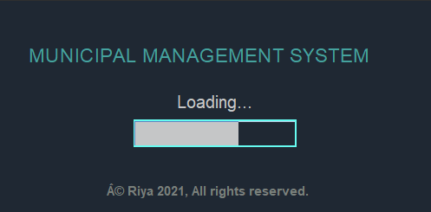

**Welcome Screen:**

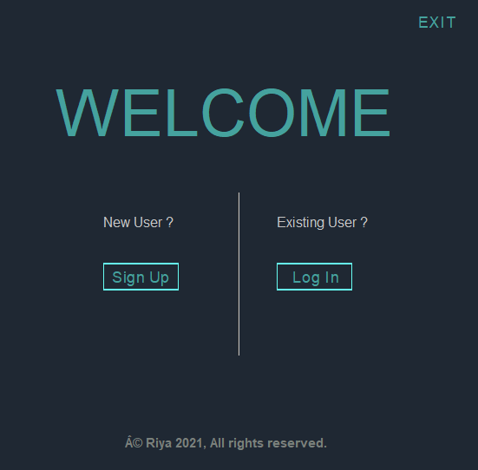

**Sign Up Screen:**

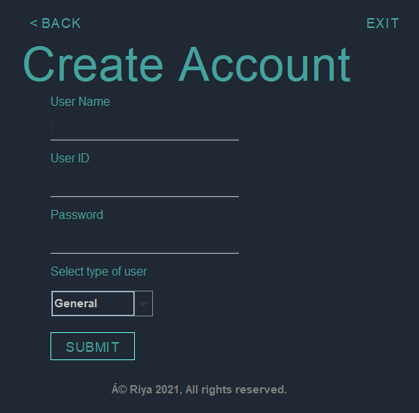

**Log In Screen:**

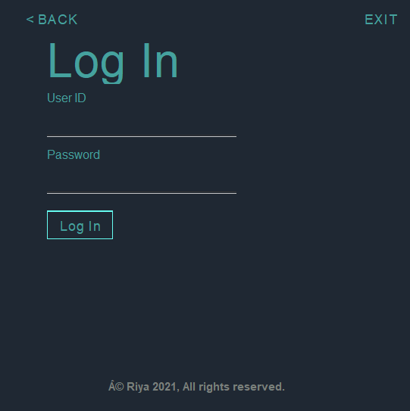

**New User Created:**

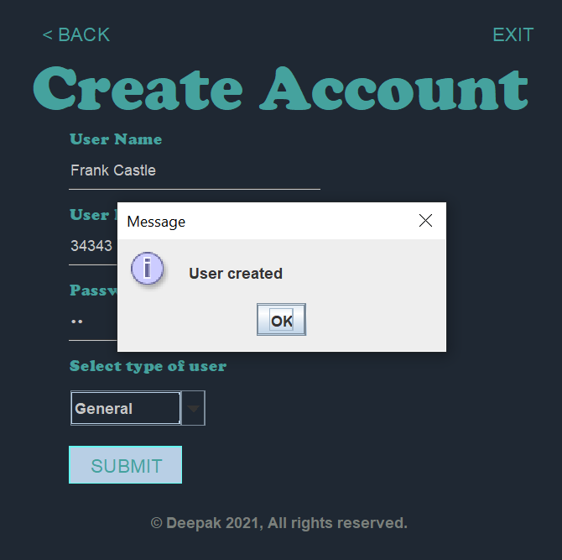

**General User Main Screen:**

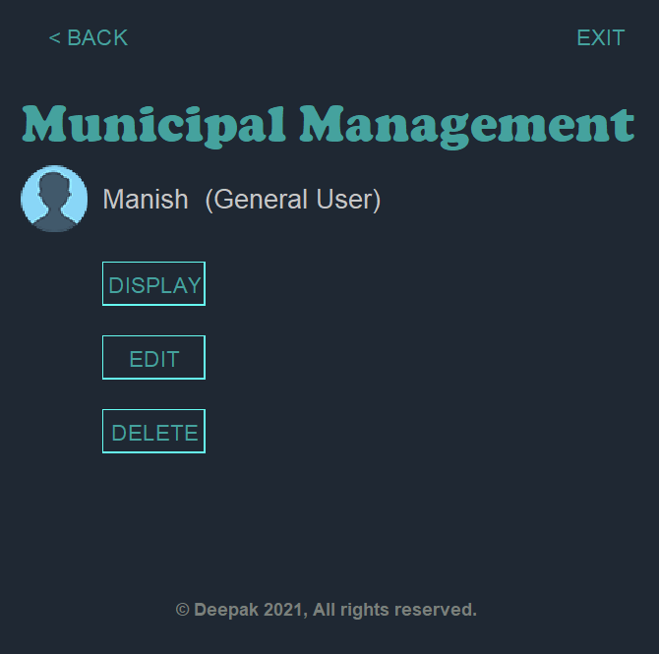

**General User Details:**

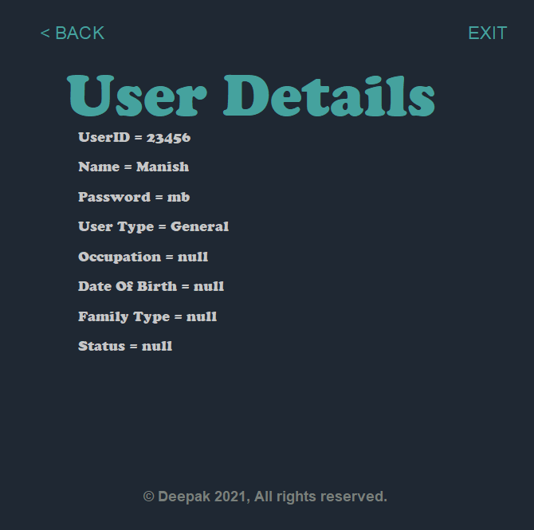

**General User Upgrade Option:**

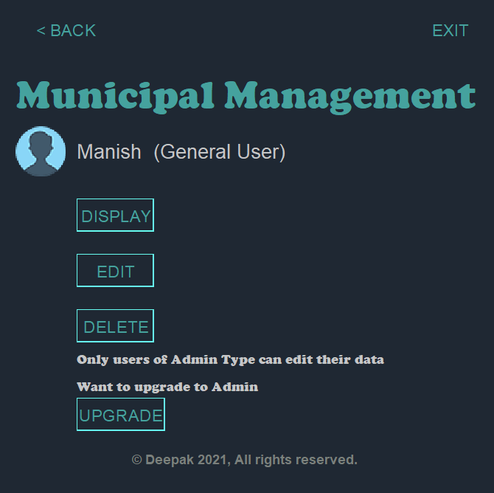

**User Deleted:**

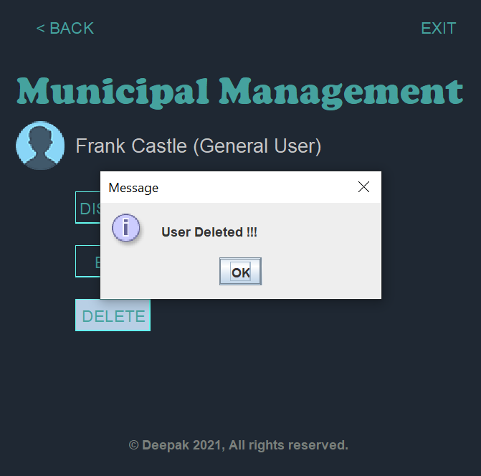

**Admin User Main Screen:**

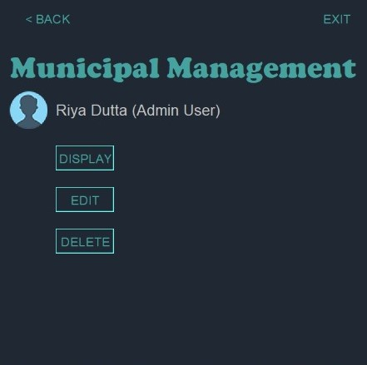

**Admin User Details:**



**Admin User Edit Screen:**

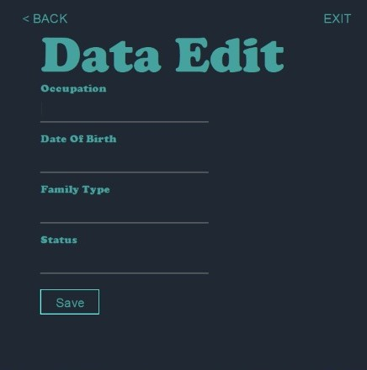

**Admin User Details:**

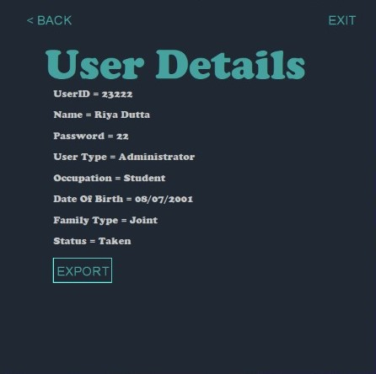

**Table Details:**

